**APEX COLLEGE**

**POKHARA UNIVERSITY**

**LAB REPORT OF**

**DOT NEW TECHNOLOGY**

**LAB-4**

**Submitted By:                                               Submitted To:**

**Ruchi Agrawal                                               Bishwomitra Adhikari**

**BCIS ‘Adware’** **Ananta Pant**

**Roll no:18**

**Objectives: To set up the Repository “ApexRestaurant.Repository Setup**

Repositories are used to create **abstraction between database access and business logic. It** supports the objective of achieving a clean separation and one-way dependency between the domain and data mapping layers. GenericRepository is a generic class and implements the IGenericRepository interface. A generic repository is often used with the entity framework to speed up the process of creating a data layer. It defines generic methods for the most common types of data operation, such as updating, fetching and deleting.

There are several benefits of repository. Some of them are:

* Minimizes duplicate query and database logic.
* Decouples your implementation from persistence frameworks or solutions.
* Provides a flexible architecture.
* Code centralization.
* Avoids code redundancy.

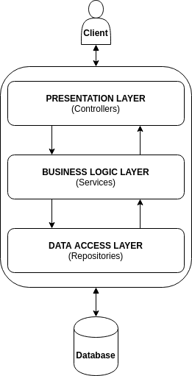

From above diagram, it is clear that the repositories separate database from rest of the application.

**Discussion:**

Firstly,

1) Create an interface IGenericRepository.cs ,

2) Create a class GenericRepository.cs

3. Likewise a class named RepositoryModule.cs is created.

4. We need to create a class “RestaurantContext.cs” and whenever we add a new table, we need to add

**public DbSet<Customer> Customers { get; set; } with respect to the table name**

5. After this create a folder name “Domain” and add a class “Customer.cs”

6. Create a folder “RCustomer” where R stands for Repository. And also create an interface “ICustomerRepository.cs” inside “RCustomer” folder

7. Create a class “CustomerRepository.cs” insider “RCustomer” folder

Now we need to build our project to ensure there are no errors,

* dotnet build
* then add the changes to git
* git add.
* git commit –m “added repository for customer”
* git push –u origin master

Now we need to perform the similar steps for other database models as per our ER diagram. And in this way our repository project is completed.

**Conclusion:**

In this lab, we learned to set up the repository and become familiar with the GenericRepository and IGenericRepository